 Pre-requisite details

s/w:

Regard3D (Modelling)

Android studio 3.2(Execution)

Blender

h/w:

Regard3D and Android studio both are heavy software so any computer with 6GB+ RAM with some latest GPU memory will work, as regard3D takes time to process data for making 3D models.

Just download android studio from the internet do next in all steps and you are done, import project then build app or run on emulator if your system has a camera.

Internet speed should be very good otherwise two heavy models will not load pot and gate model.

Wait 20 seconds on home page it will load the database file.

Creation of 3D Model

Software: Regard 3D x64 0.9.5

Software Source: [http://www.regard3d.org/](https://www.youtube.com/redirect?v=GaYfpGcXxmA&redir_token=3ZTAlGYIL7ORO3rzwJJIR0CvIIx8MTUyNjc0MTU4NkAxNTI2NjU1MTg2&event=video_description&q=http%3A%2F%2Fwww.regard3d.org%2F)

Tutorial used: <https://www.youtube.com/watch?v=GaYfpGcXxmA>

Process:

* Download Regard 3D setup from the software source and install it on your system.
* Open Regard 3D, create a new project and import all the necessary images you have for 3D Modeling.
* Select your picture set then click on the compute matches and change the default settings as per the screenshot i.e. set keypoint sensitivity to minimal(0.001) and matching ratio to Ultra(0.9) and click Ok.

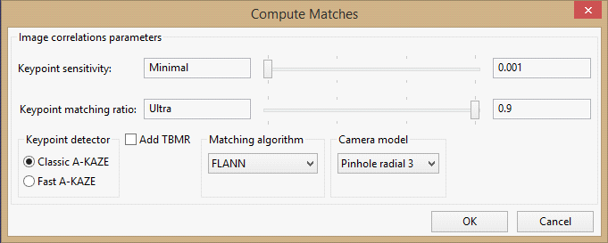

* You can check keypoint and matches by clicking on show matching results.. Then you can open these by the option of Open preview window. 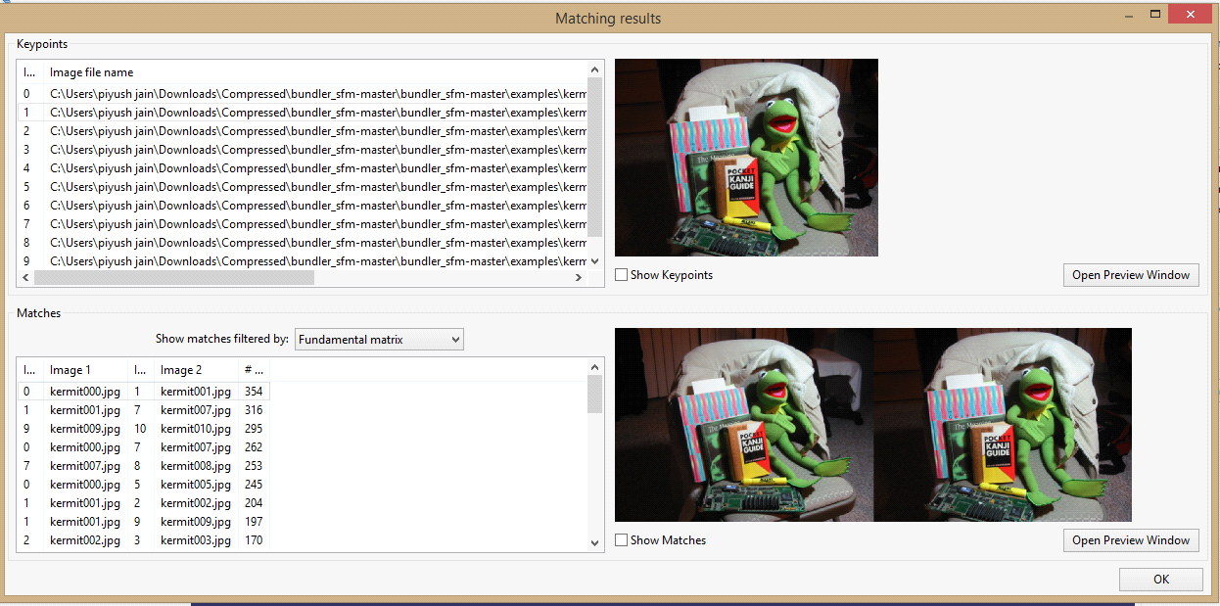 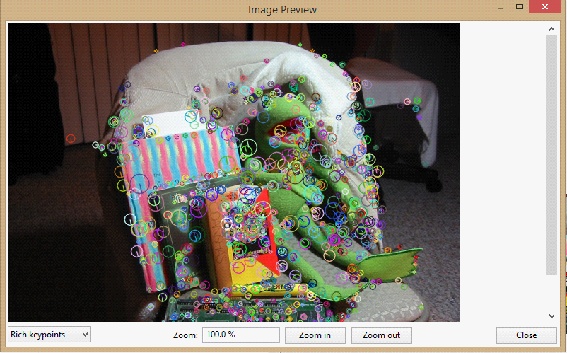 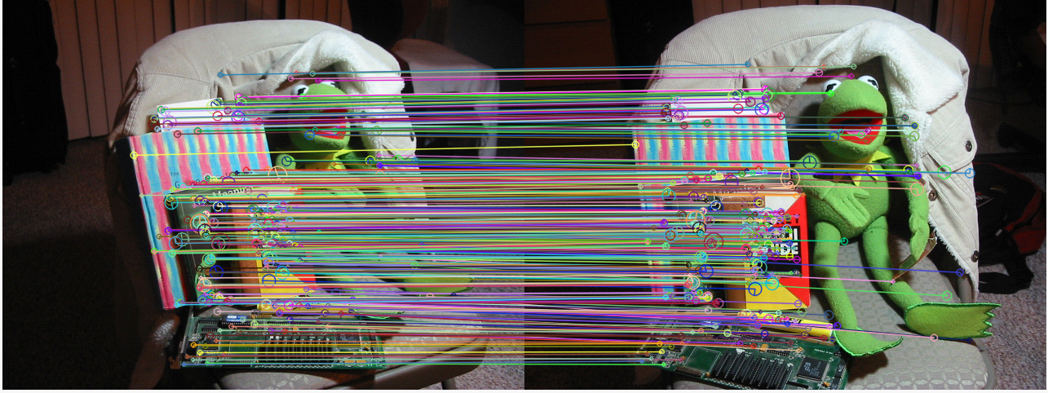
* Now click on Triangulation.. keep the setting as per screenshot ,You have to change the method from Incremental to Global structure from motion then click Ok. 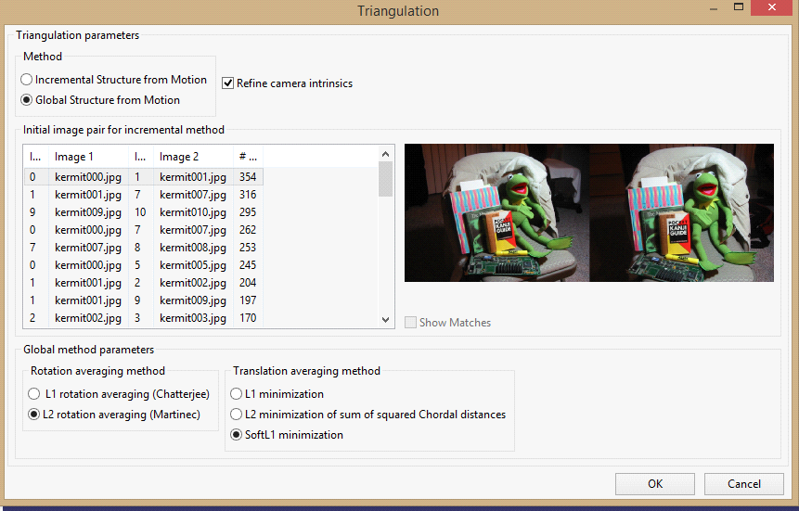
* Select the option named Create dense pointcloud from the sidebar keep the default setting click Ok. In my system default setting were like this. 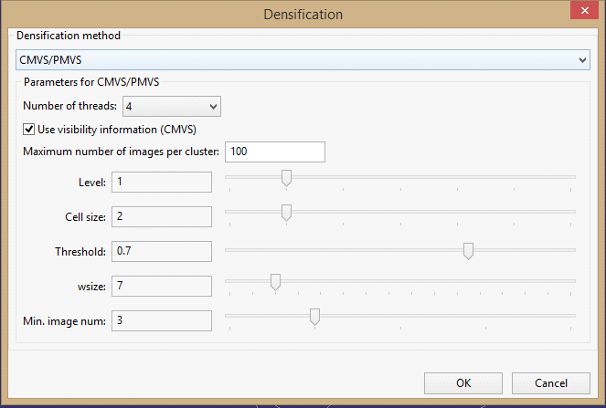
* Now if you rotate the globe in the middle of interface, you will get model like this.

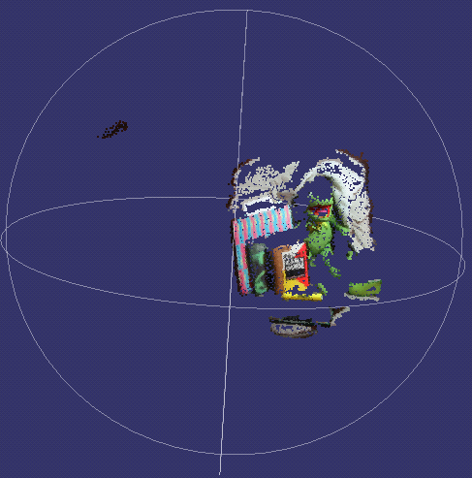

* Click on the option of Create surface.. you can select two different colorization method either colored vertices or texture. 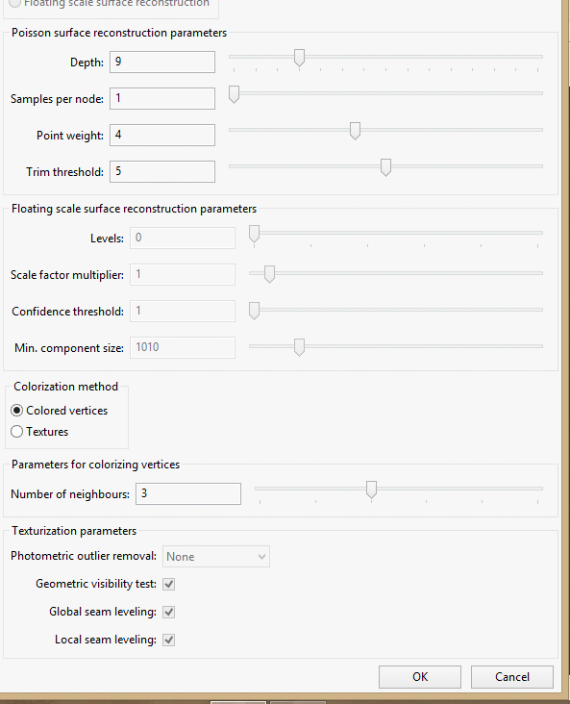
* If you choose Colored vertices that will generate this 3D model. 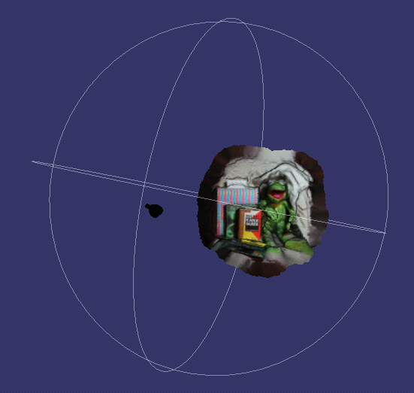

Or if you choose texture that will give you this 3D model. 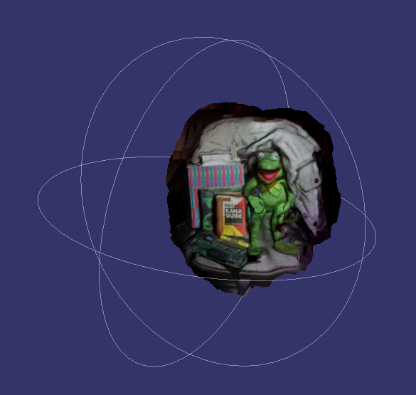

Now how to reduce obj file size with blender:

1.Import obj file in blender[File->Import->Wavefront(.OBJ)]

Note all the texture(.png or .jpg) and material file(.mtl) and .obj file should be in same folder otherwise texture will not load on blender.

2. When model loads press Alt+z that is the shortcut key to load texture. You can select texture from bottom menu too right side of object mode.

3.Select the object by right click and choose the option of modifiers in the right corner as show in screen shot.

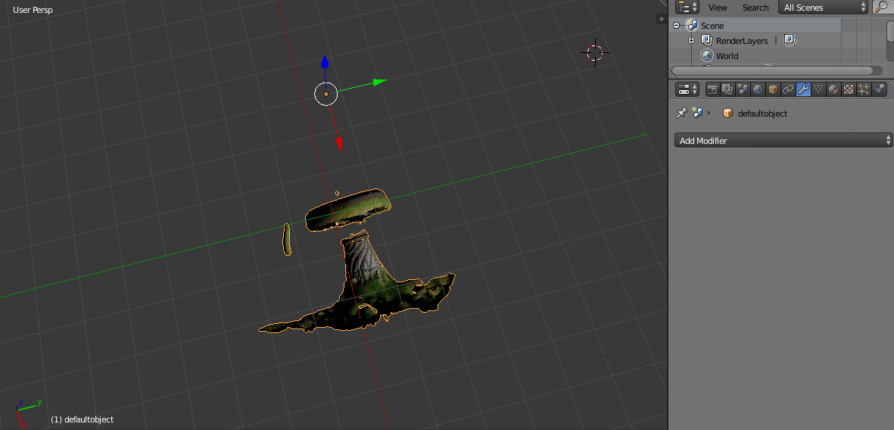

4.Now click on add modifiers in the generate column, you will get ratio option if your obj file size is 80mb if you have enter 0.5 in ratio then click on apply obj file size will be of 40mb if you export.so based on your obj file size choose ratio and export obj file in some folder[File->export->wavefront(.obj)]

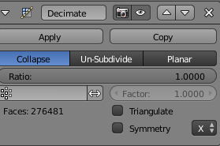

How to make changes in files in order to upload model in proper way:

5. Now you have your obj file with reduced size. Mtl and texture file are already their from regard3D export in your model folder.

Note: Check your mtl file every “map_Kd texture.png” line has jpg file name only not a path as all texture is in same folder

6. Rename your “model.obj” and “model.mtl” file to “model_obj” and “model_mtl” respectively.

7.Create zip of this folder name it as model.zip and upload it on amazonS3 buket.

8.Now download example.txt from S3 bucket and update one more line for new model and upload the updated file again on S3.

Note:Don’t delete the old example.txt ever from S3 bucket just upload the new one it will replace the old one.

8. If you have some related video of model upload it as model.mp4

Note: If video is in avi or other format please covert it to mp4 file online then upload as videoview supports mp4 always.

9. If you have some animated video of model upload it as model1.mp4

10. If you have some information of model upload it as model.txt

You are done!

LOADING OF MODEL

1.Now you have your obj file with reduced size. Mtl and texture file are already their from regard3D export in your model folder.

Note: Check your mtl file every “map_Kd texture.png” line has jpg file name only not a path as all texture is in same folder

2. Rename your “model.obj” and “model.mtl” file to “model_obj” and “model_mtl” respectively.

3.Create zip of this folder name it as model.zip and upload it on amazonS3 buket.

4.Now download example.txt from S3 bucket and update one more line for new model and upload the updated file again on S3.

Note:Don’t delete the old example.txt ever from S3 bucket just upload the new one it will replace the old one.

5. If you have some related video of model upload it as model.mp4

Note: If video is in avi or other format please covert it to mp4 file online then upload as videoview supports mp4 always.

6. If you have some animated video of model upload it as model1.mp4

7. If you have some information of model upload it as model.txt

You are done!

**Amazon Web Service (AWS S3)**

1.CREATE AN AWS ACCOUNT: -

You must create an AWS account by using any verified email id.

Procedure to create an AWS account: -

<https://docs.aws.amazon.com/polly/latest/dg/setting-up.html>

2.After Signing up, Create an AWS S3 bucket: -

<https://docs.aws.amazon.com/quickstarts/latest/s3backup/step-1-create-bucket.html>

Or create a new bucket: -

<https://www.youtube.com/watch?v=uiDo-hmOlM8>

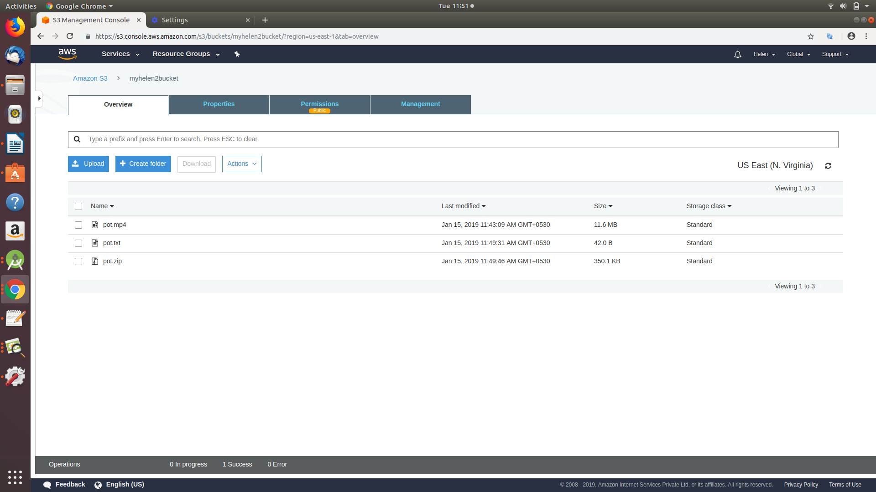

2.1. Give unique name to your bucket

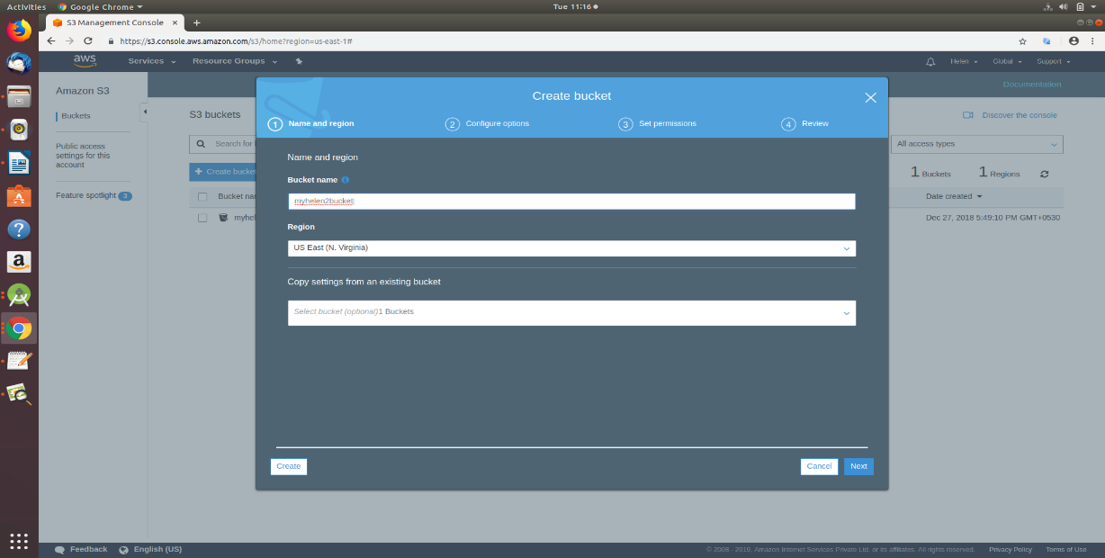

2.2Configure your account.

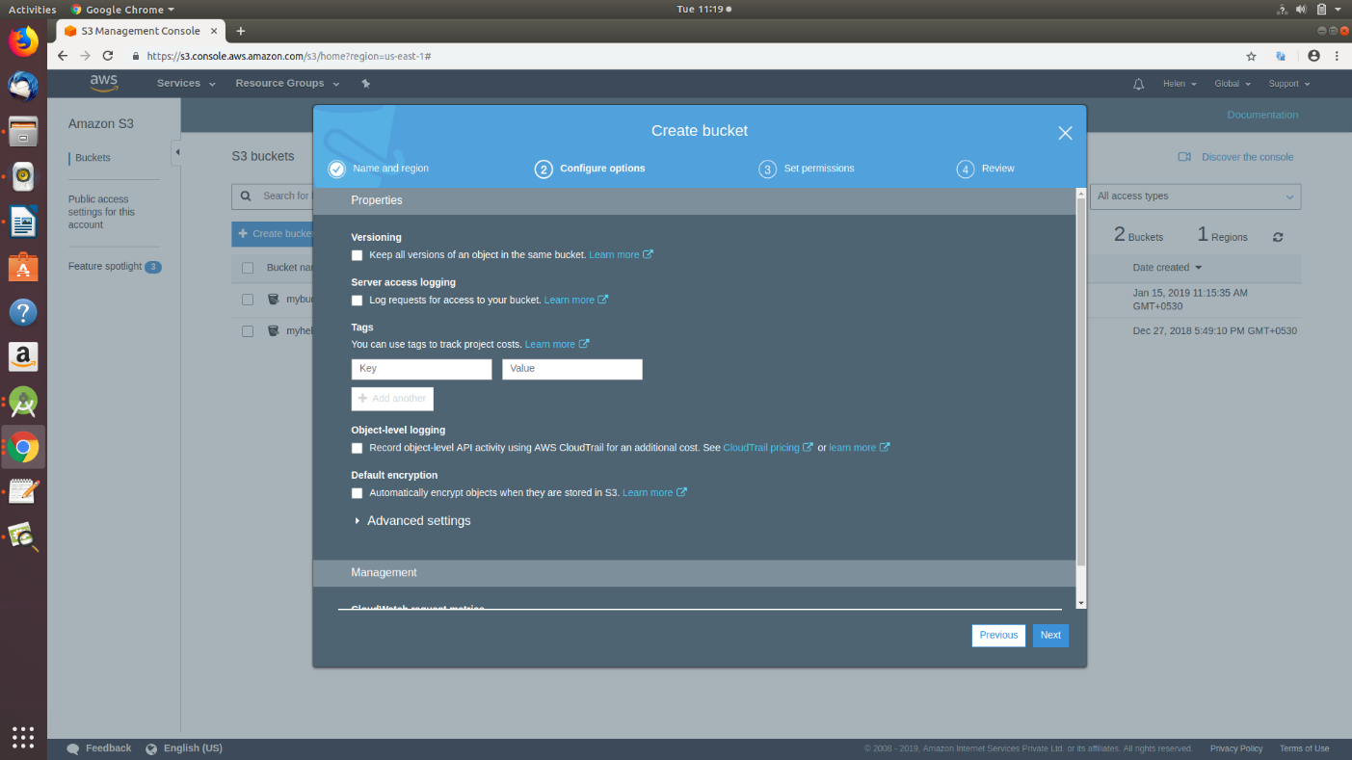

2.3. Give access permissions.

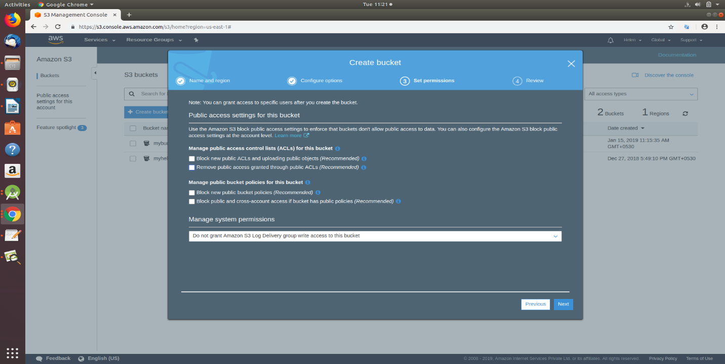

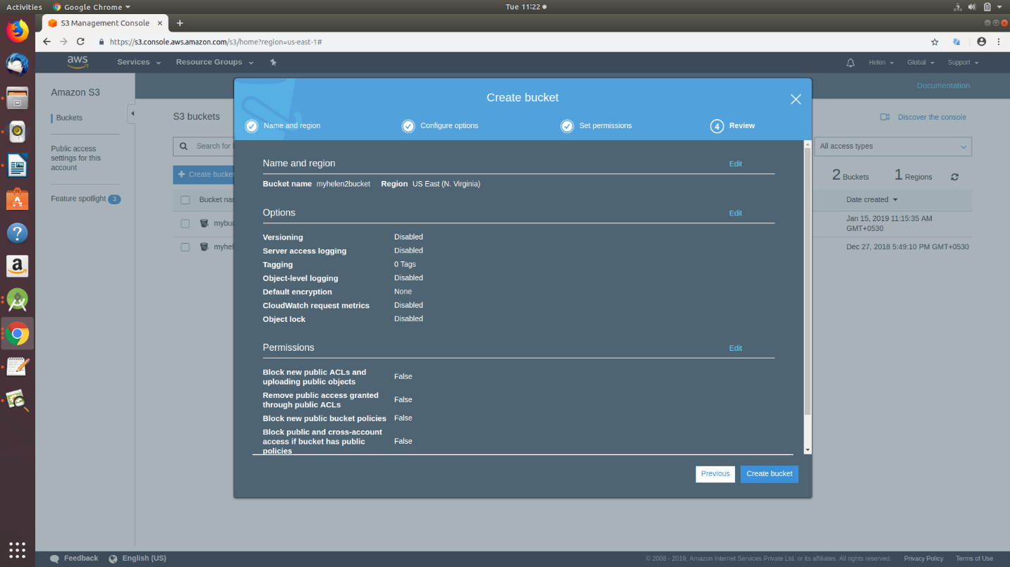

2.4. Your Bucket is now ready.

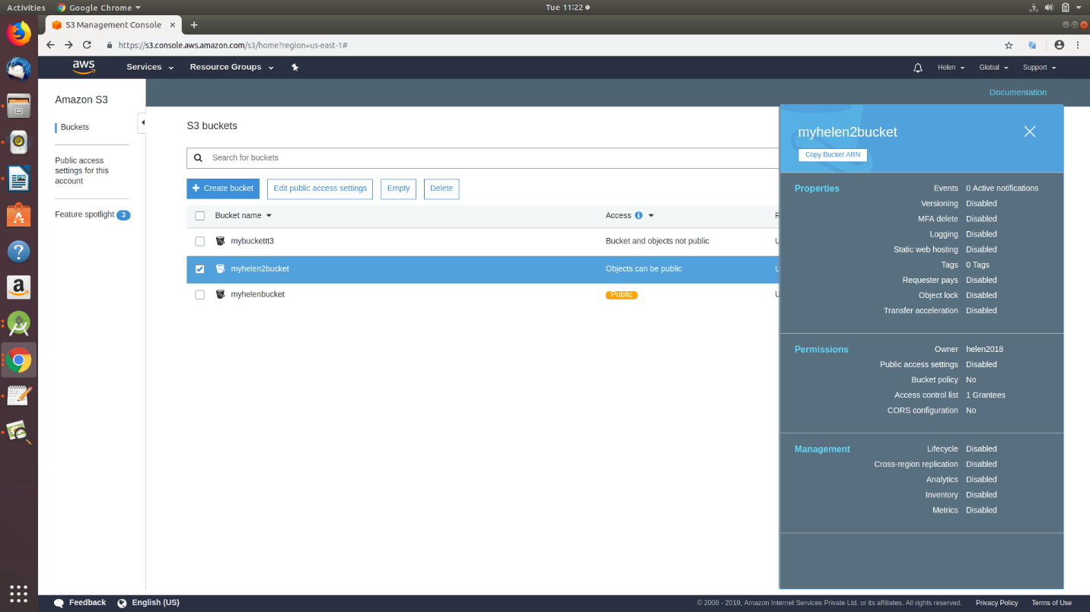

2.5. Make your bucket public as shown.



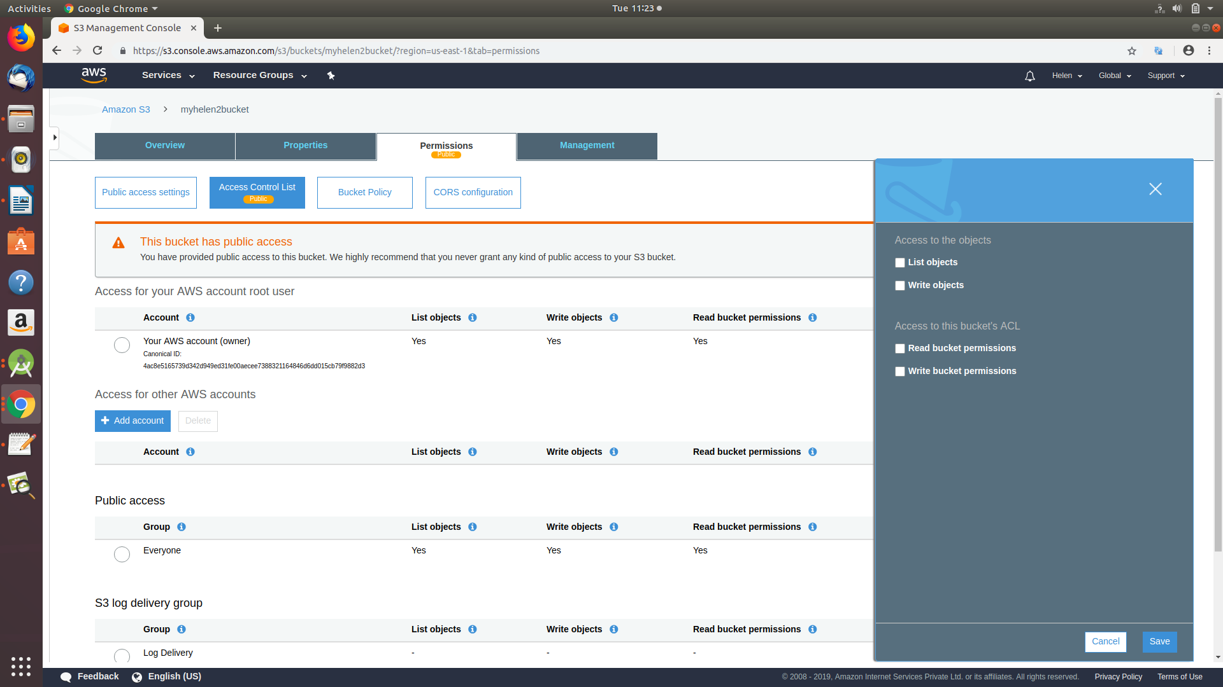

3.Uploading of models:-

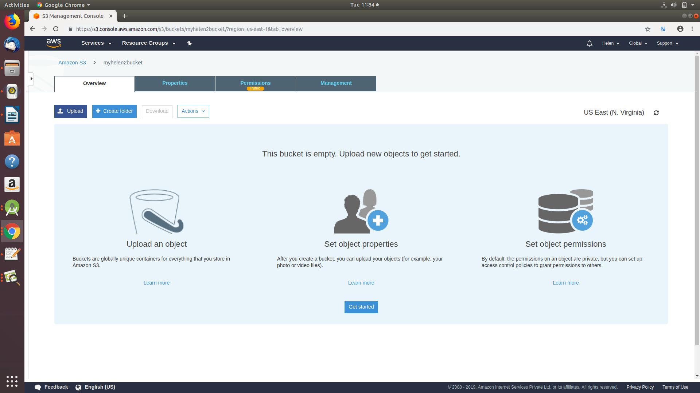

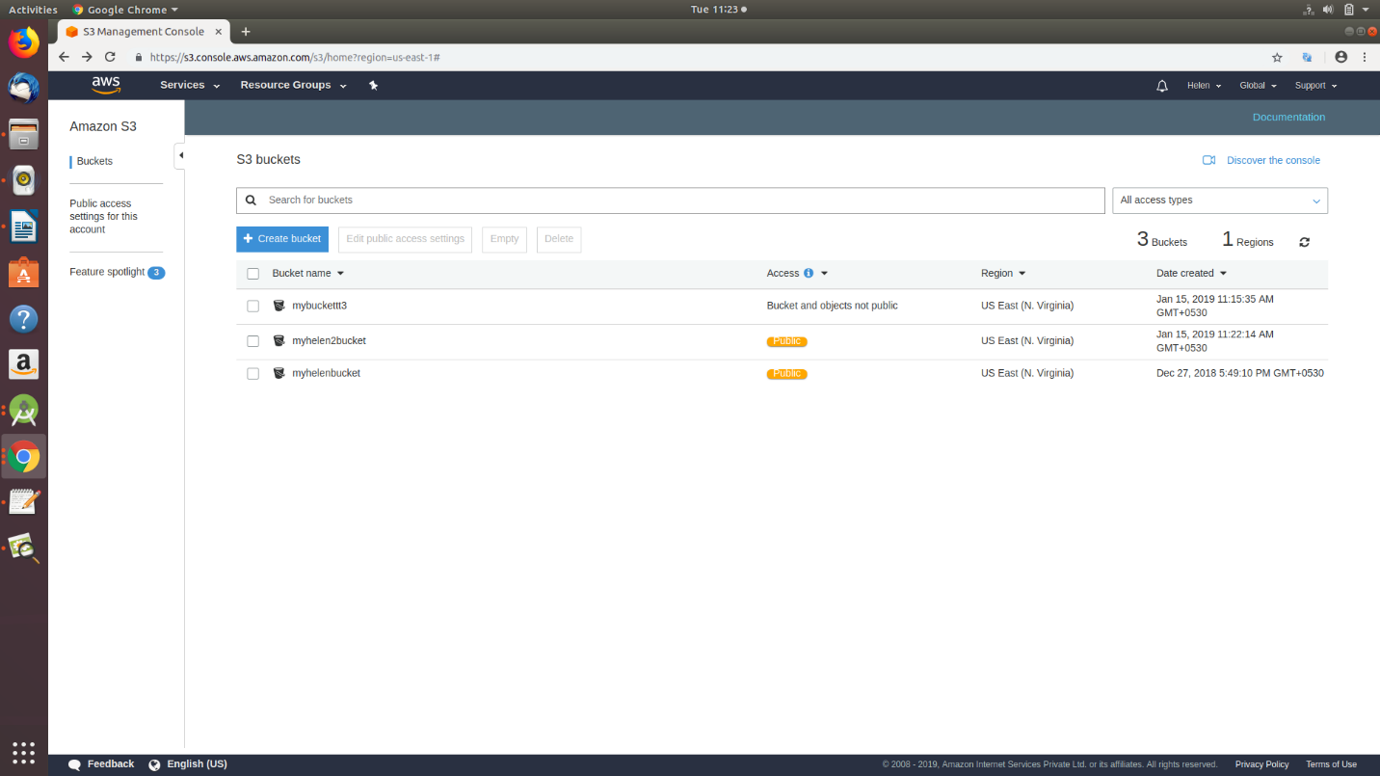

4. After uploading select the file you want to download and use the highlighted url to make changes in your code.

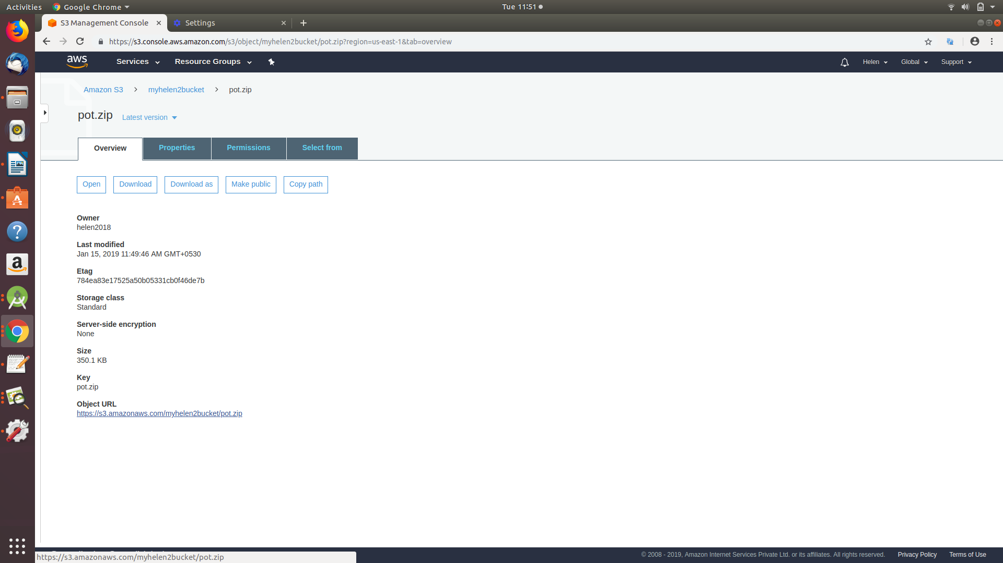

5.Upload an example.txt file containing your model’s information in the format: -

(unique id, model name, download link)

You just must add another model like this only and add the necessary details in example.txt file

for the new models.

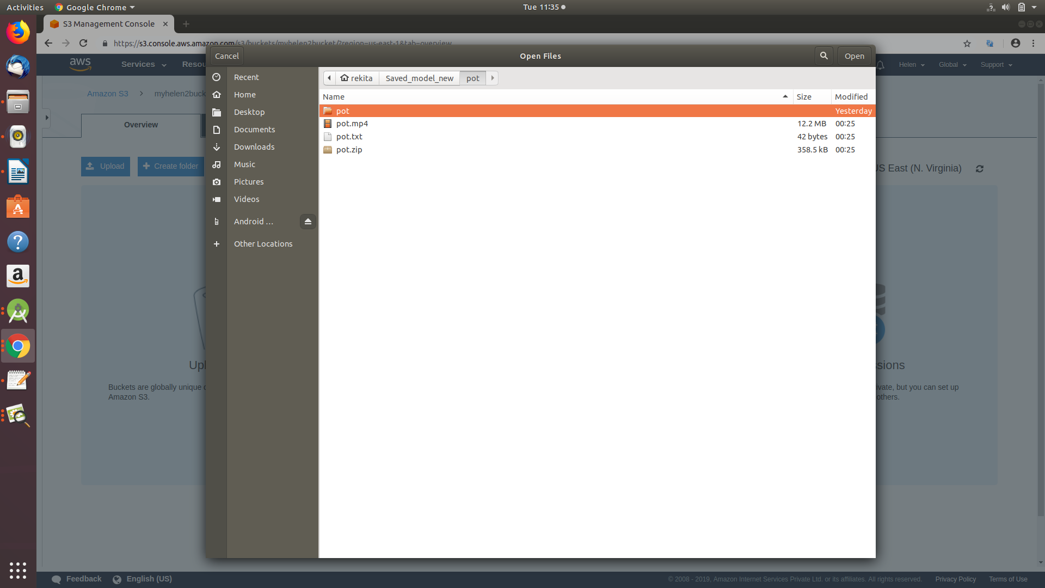

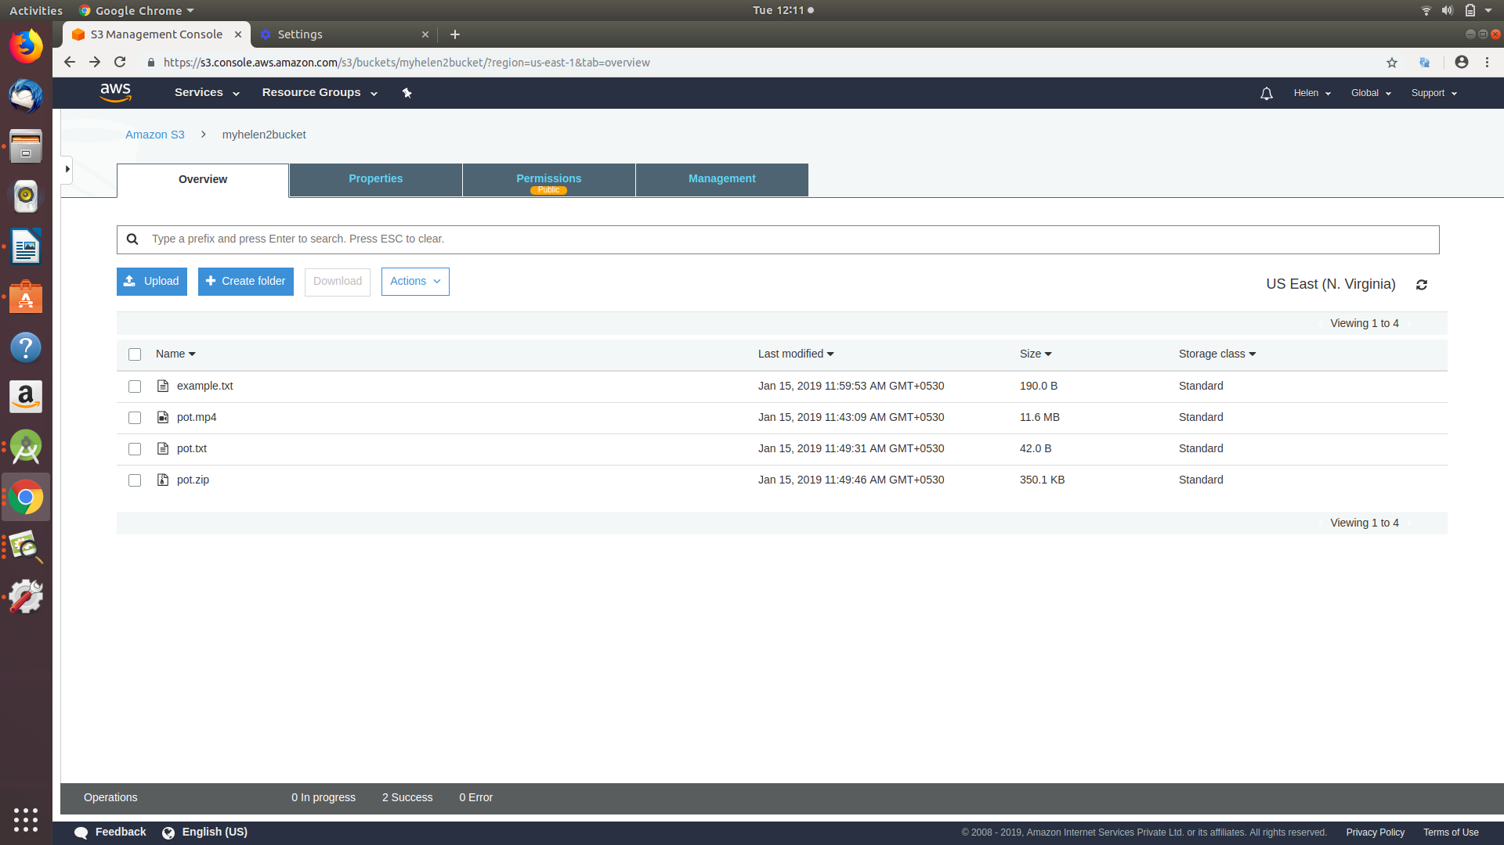

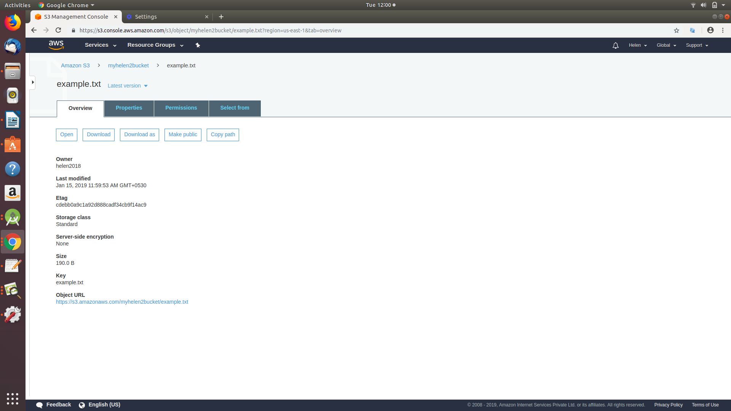

6. Here you have to make changes in code, where-ever you see the amazon s3 link , replace it with your bucket link.

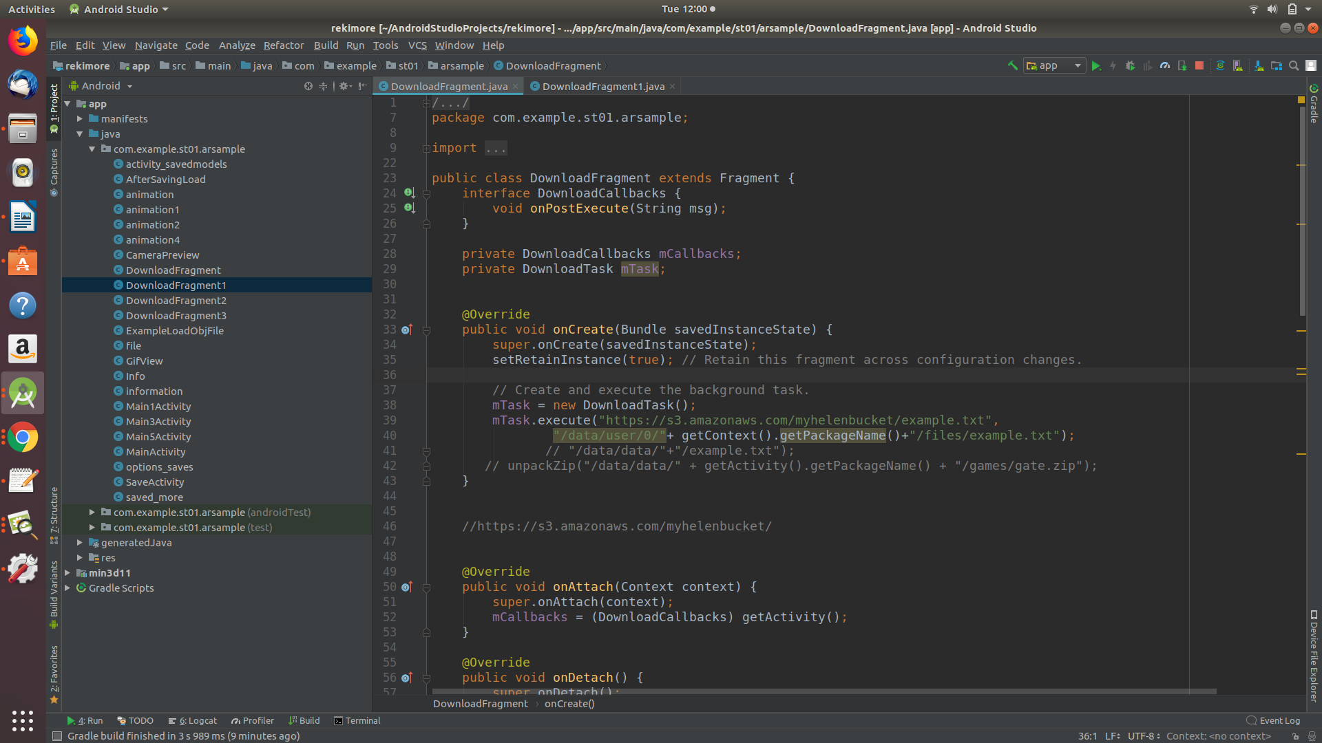

Look through your whole source code and change all the amazon s3 links with your respective s3 bucket links.